Legal Swarms in Post-Injunction US

GB_Feature_Swarms_v2

1. Summary
The June 2025 Supreme Court ruling in Trump v. CASA marks a seismic shift: unjust executive actions can now go unchallenged—unless everyday people organize locally and act fast. GroupBuild was built for moments like this.
This is how the platform could evolve to ensure that “We The People” are not left without a legal path to push back:
(a) which existing features now offer increased strategic value, and
(b) which new features could be prioritized for development.
Our goal would be to ensure GroupBuild remains the an effective civic organizer, even when users have to work under an increasingly fragmented and ineffective legal system.

2. Risks and Realities
- Lower courts may no longer issue blanket injunctions against unconstitutional executive orders.
- Legal remedies must be pursued at the local level or via named plaintiffs in multi-district filings.
- Municipalities, counties, and state officials will now play a larger role in protecting civil rights.

2.1. What Users Now Face
If this is your new reality:
- You live in a city where an unconstitutional executive order just went into effect.
- Your school board, city council, or mayor hasn’t challenged it.
- You can’t find a lawyer, and no national Group has launched a lawsuit on your behalf.
Then GroupBuild is your blueprint to turn isolation into coordination, frustration into strategy.

3. Strategic Position
GroupBuild can be marketed not only as a digital democracy platform, but now as a legal force multiplier under fragmented federal protections. Future-facing language should frame GroupBuild as:
“The civic backbone for defending rights when the courts delay, and the system retreats.”
Example Taglines:
- “Build a Group, a Case and an Uprising”
- “Swarm Fast, Stand Firm, Stay Free”
- “Your Region. Your Rights. Your Recourse”
- “Law Doesn’t Scale. People Do”
- “From Petition to Plaintiff. From Hashtag to Hearing”
- “Verified. Mobilized. Legally Recognized”
- “When the Constitution Lags, the Swarm Leads”

4. Highlights for Future Marketing:

3.1. Localized Organizing Capabilities
- GroupBuild's location-focused Groups to be allowed to show a region-specific legal standing.
- “Start a Group in Your City” may be re-framed as “Protect a Region from Executive Overreach.”
3.2. Stakeholder Verification Tools
- Verified members can “dox” as potential plaintiffs, municipal influencers, or policy witnesses.
- Marketing should stress: “Verified membership isn’t just for reputation—it’s for legal action.”
3.3. Decentralized Strategy Sync
- GroupBuild’s ability to coordinate parallel local actions now confers strategic legal advantage.
- Promote templates for class-action formation, public declarations, and synchronized city campaigns.
3.4. GroupBuild as a Legal Signal Amplifier
- Position GroupBuild as a tool that helps lawyers identify regions of likely success for legal action
- By revealing where public will is already organized.
- Relevant hashtags: #LegalSwarm, #DecentralizeTheFight, #PlaintiffPower, #LocalActionWins

5. Suggested Features:

5.1. Legal Swarm “Coordination Module”
Goal: Enable geographic-based legal coordination and documentation gathering
User Benefit: Join or initiate collective legal resistance with peers
Growth Hack: Promote “Join a Swarm” CTA on city-based GroupBuild pages
Viral Hook: Regional leaderboard showing “Most Legally Active Cities This Week”

5.2. Class Certification Helper
- Automate the collation of verified users and shared experiences to assist law firms in certifying class actions.
- Create a dataset export compatible with nonprofit litigation partners.

5.3. Impact Map + Injunction Status Overlay
- Interactive map showing executive order enforcement vs. local resistance.
- Overlay zones with: “Protected,” “Partially Enjoined,” or “At Risk.”

5.4. Named Plaintiff Recruitment Tool
- Workflow for local campaigns to identify and prep qualified named plaintiffs.
- Include a secure interview module for volunteer legal screening.

5.5. Municipal Targeting Toolkit
- Provide users with briefing materials and outreach scripts to activate city councils or county commissioners.
- Track engagement progress with local officials to demonstrate pressure efficacy.

6. Competitors/Partners
Platform | Legal Coordination | Localized Swarm Tools | Status Awareness | Viral Actionability | Verdict
GroupBuild | ✅ Full | ✅ Yes | ✅ Planned | ✅ Yes | Best Grassroot
Action Network | ❌ No | ✅ Partial | ❌ No | ✅ Yes | Supplemental
Mobilize.us | ❌ No | ✅ Events | ❌ No | ✅ Yes | Supplemental
ACLU/EFF/SPLC | ✅ Lawyers | ❌ No | ✅ Reactive | ❌ Low | Partnerships
Change.org | ❌ No | ❌ No | ❌ No | ✅ High | Visibility Only
DemocracyOS/etc. | ❌ No | ✅ Municipal Input | ❌ No | ❌ No | Policy Design
AI Legal Tools | ⚠️ Growing | ❌ Not Yet | ✅ Sometimes | ❌ Not Social | Future Threat

GroupBuild wins by:
- Owning “rapid legal organizing” as a market segment/category, and
- Becoming a feeder and amplifier for organizations like ACLU
- Giving power to local communities and regions that large organizations don't reach.

7. Next Steps
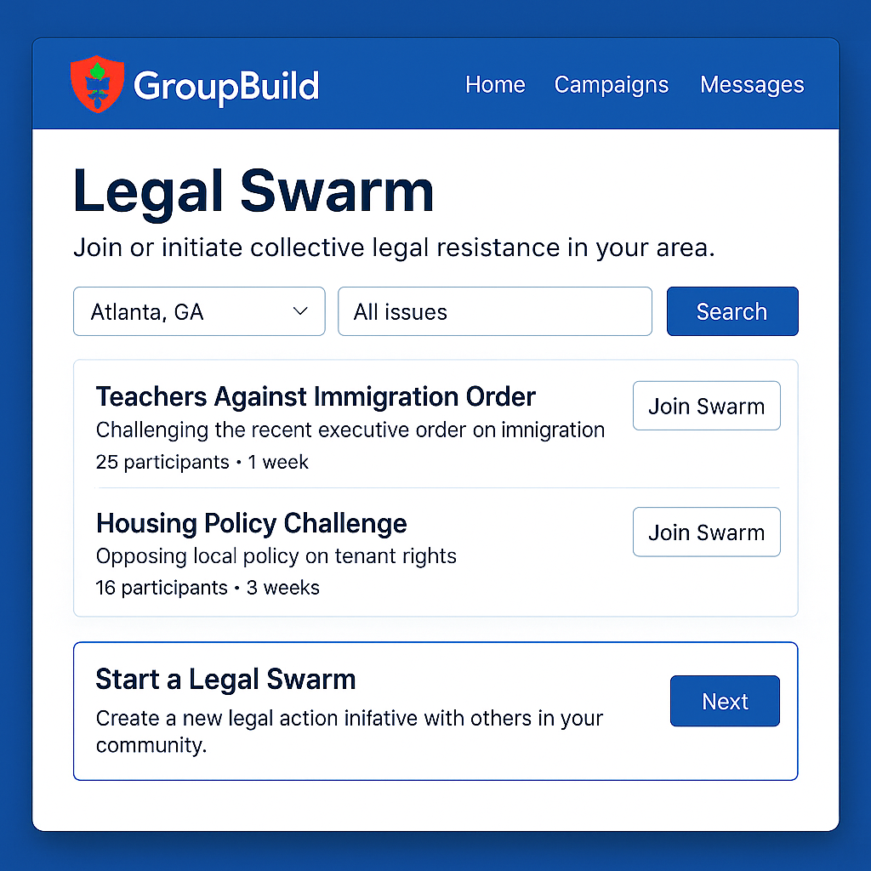
- Design prototype Legal Swarm Module.
- Marketing decks to include post-injunction message.
- Identify legal advocacy groups for launch-partnerships.
- Prepare marketing campaign for regional plaintiff recruitment.
- Create video-short about successful legal swarm mobilization.

